Town of Somerset Bicentennial Shirts

Support Somerset Bicentennial
by purchasing a
commemorative 2023 shirt!
(Similar design to sketch at left)

Short Sleeve $15 ($17 XXL)
Long Sleeve $20 ($22 XXL)

Color: White OR Light Blue

Mail order form and make checks payable to:
Somerset Bicentennial Committee, Inc.
PO Box 264
Barker, NY 14012

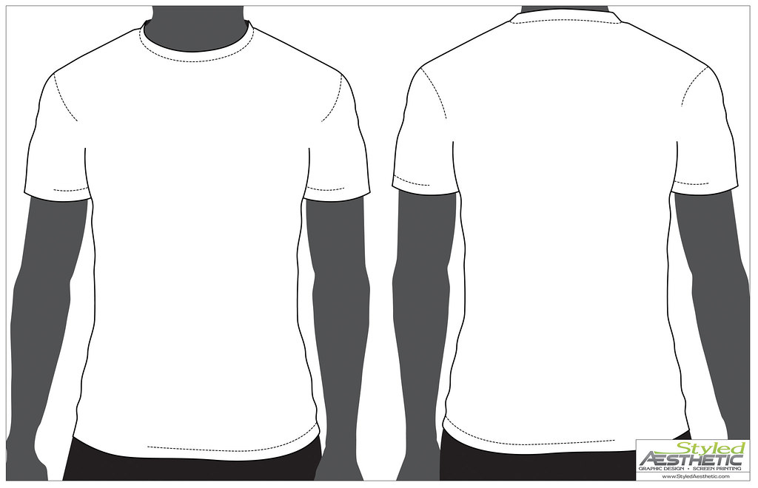
July 21 - 23, 2023

This Photo by Unknown Author is licensed under CC BY
 | Short Sleeve White  $15/$17 | Long Sleeve White  $20/$22 | Short Sleeve Blue  $15/$17 | Long Sleeve Blue  $20/$22
Small
Medium
Large
XL
XXL

Total Cost: _______________________________________________________________

Name: ___________________________________________________________________

Phone Number: ____________________________________________________________

