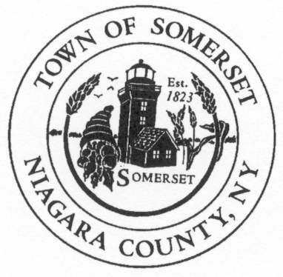
Jon D. Miller
Chief of Police
Town of Somerset
8700 Haight Road P.O. Box 368
Barker, NY 14012-0368

Phone: 716-255-0503
CELL: 585-356-1728
jdm74apd@yahoo
DATE: October 2nd, 2019

TO: Somerset Town Board

RE: Police Report for September 2019 ____________________________________________________________________________________

PATROL REPORT

1. TSPD provided 215.5 hours of strategic car patrol coverage each night during September and patrolled approximately 2078 miles.

2. All service calls are logged and recorded in the Niagara County Sheriff's E-911 Computer Aided Dispatch (CAD) system, including house/business checks and vehicle stops. This accountability mechanism is vitally important to assess the effectiveness of the agency and the overall service needs of our community. 284 service calls were officially logged by TSPD for the month of September.

3. TSPD submitted (53) fifty-three incident reports into the Niagara County’s IBR (Incident Based Reporting System). The following is a report breakdown for the month of September:

15 agency assists, 2-harassments, 1-motor vehicle accident, 8-suspicious condition complaints, 1-warrant attempt, 1-town ordinance violation, 1-welfare check, 1-noise complaint, 1-mental health investigation, 3-animal complaints, 15-police service calls, 3-traffic complaints, 1-burglary.

4. TSPD issued forty-four (44) citations for violations of the Vehicle and Traffic Law during the month of September. Twenty-one (21) drivers received cautionary warnings.

6. Property checks- TSPD is required to provide property checks as requested by residents at least one time per shift and there are also a number of business/municipal buildings which are required to be inspected. TSPD logged 166 house and business checks were conducted during the month of September.

7. During September the SRO handled (27) incidents/student contacts that required intervention, as well as security details at the Barker School homecoming event and homecoming dance.

*Notable Mention
On 09/18/2019 our department assisted the NCSO, DSP and multiple other agencies in a county wide warrant execution. Through 2 days of the detail 370 warrants executions were attempted, with 112 suspects served and processed.
Officer Herlofson has completed her certified field training and began duties on 09/30/2019.

