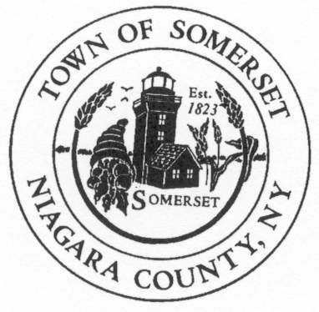
Jon D. Miller
Chief of Police
Town of Somerset
8700 Haight Road P.O. Box 368
Barker, NY 14012-0368

Phone: 716-255-0503

jdm74apd@yahoo
DATE: October 3rd, 2018

TO: Somerset Town Board

RE: Police Report for September 2018 ____________________________________________________________________________________

PATROL REPORT

1. TSPD provided 190 hours of strategic car patrol coverage each night during September and patrolled approximately 2071 miles. Of the 190 hours of coverage 98.5 hours were 2 man coverage per NYS training doctrine for new hire employee’s.

2. All service calls are logged and recorded in the Niagara County Sheriff's E-911 Computer Aided Dispatch (CAD) system, including house/business checks and vehicle stops. This accountability mechanism is vitally important to assess the effectiveness of the agency and the overall service needs of our community. 215 service calls were officially logged by TSPD for the month of September.

3. TSPD submitted twenty-four (24) incident reports into the Niagara County’s IBR (Incident Based Reporting System). The following is a report breakdown for the month of September:

6- traffic complaints, 3-animal complaints, 2-Barker Fire Dept assists, 2-police service calls, 3-suspicious condition, 2-domestic incident, 1-DWI arrest, 1-UPM arrest, 2 -agency assists, 1-citizen assist, 1-noise complaint.

4. TSPD issued thirty-five (35) citations for violations of the Vehicle and Traffic Law during the month of September, with thirty-five (35) additional drivers receiving cautionary warnings. (1) vehicle was also towed for the DWI arrest.

6. Property checks- TSPD is required to provide property checks as requested by residents at least one time per shift and there are also a number of business/municipal buildings which are required to be inspected. TSPD logged 121 house and business checks were conducted during the month of September.

Notable mention
TSPD has secured a tablet that has now been integrated into patrol use to better document photographic evidence at crime scenes and assist the Niagara County Districts Attorney’s office in crime convictions.

