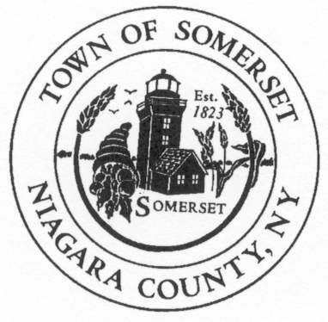
Jon D. Miller
Chief of Police
Town of Somerset
8700 Haight Road P.O. Box 368
Barker, NY 14012-0368

Phone: 716-255-0503
CELL: 585-356-1728
jdm74apd@yahoo
DATE: July 3rd, 2019

TO: Somerset Town Board

RE: Police Report for June 2019 ____________________________________________________________________________________

PATROL REPORT

1. TSPD provided 193.5 hours of strategic car patrol coverage each night during June and patrolled approximately 2308 miles.

2. All service calls are logged and recorded in the Niagara County Sheriff's E-911 Computer Aided Dispatch (CAD) system, including house/business checks and vehicle stops. This accountability mechanism is vitally important to assess the effectiveness of the agency and the overall service needs of our community. 248 service calls were officially logged by TSPD for the month of June.

3. TSPD submitted (42) forty-two incident reports into the Niagara County’s IBR (Incident Based Reporting System). The following is a report breakdown for the month of June:

3-Domestic incidents, 5 agency assists, 4-MVA, 4-warrant attempts, 1-welfare checks, 8-traffic complaints, 13-police service calls, 1-animal complaints, 1-larcenys, 2-harassments,
*1 warrant arrest/1 MHA arrest w/possession of a controlled substance

4. TSPD issued forth-seven (47) citations for violations of the Vehicle and Traffic Law during the month of June. Twenty-six (26) drivers received cautionary warnings.

6. Property checks- TSPD is required to provide property checks as requested by residents at least one time per shift and there are also a number of business/municipal buildings which are required to be inspected. TSPD logged 133 house and business checks were conducted during the month of June.

7. The TSPD SRO had sixteen (16) juvenile interventions, and taught 2 classes to the students of Barker Central School for the month of June.

*Notable Mention
Officer Bradt tendered his resignation as a Somerset Police Officer effective 06/30/2019. Officer Bradt has taken full time employment with the Town of Niagara Police Dept.

