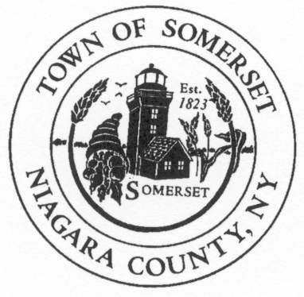
Jon D. Miller
Chief of Police
Town of Somerset
8700 Haight Road P.O. Box 368
Barker, NY 14012-0368

Phone: 716-255-0503
CELL: 585-356-1728
jdm74apd@yahoo
DATE: November 7th, 2019

TO: Somerset Town Board

RE: Police Report for October 2019 ____________________________________________________________________________________

PATROL REPORT

1. TSPD provided 214 hours of strategic car patrol coverage each night during October and patrolled approximately 2227 miles.

2. All service calls are logged and recorded in the Niagara County Sheriff's E-911 Computer Aided Dispatch (CAD) system, including house/business checks and vehicle stops. This accountability mechanism is vitally important to assess the effectiveness of the agency and the overall service needs of our community. 315 service calls were officially logged by TSPD for the month of October.

3. TSPD submitted (42) forty-one incident reports into the Niagara County’s IBR (Incident Based Reporting System). The following is a report breakdown for the month of October:

13 agency assists, 1-larceny, 1-harassments, 2-motor vehicle accident, 3-suspicious condition complaints, 2-domestic incidents, 1-juvenile complaint, 1-criminal mischief, 2-noise complaint, 1-mental health investigation, 6-animal complaints, 7-police service calls, 2-traffic complaints.

4. TSPD issued thirty-eight (38) citations for violations of the Vehicle and Traffic Law during the month of October. Thirty-one (31) drivers received cautionary warnings.

6. Property checks- TSPD is required to provide property checks as requested by residents at least one time per shift and there are also a number of business/municipal buildings which are required to be inspected. TSPD logged 204 house and business checks were conducted during the month of October.

7. During October the SRO handled (10) ten incidents/student contacts that required intervention, as well as presenting classroom presentations on various topics.

*Notable Mention
Officer Jonathan Wolcott was hired as a police officer to serve the Town of Somerset. Officer Wolcott is completing his formal police training at the Niagara Law Enforcement Academy.

